**PT Tanjungenim Lestari**

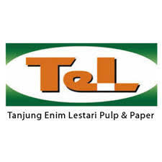

2019

**Report**

**3rd Quarter (October - December)**

**Local Community Development**

**Summary**

Local Community Development continues to provide PT TEL CSR programs to communities around the company. Some programs are the continuation of previous programs in 2nd quarter (July - September 2019), and several new programs in the 3rd quarter in the period of October - December 2019.

1. **Education**

* Monitoring scholarship program scholarship students at the Academy of Pulp and Paper Technology (ATPK) Bandung (4 students) and Polytechnic of Sriwijaya – Palembang (19 students), also YP TEL school operations. On November 11, 2019 4 students of scholarship program at Polytechnic of Sriwijaya – Palembang and 4 students of ATPK Bandung that has graduated on August and September 2019 has joint wit PT Tanjungenim Lestari Pulp and Paper as employees
* Support school event at SMAN 2 Prabumulih, SMAN 1 Belimbing and SDN 37 Rambang Dangku

1. **Local economic empowerment**

* Monitoring the development of local businesses that have been supported by CSR of PT TEL such as tempe and tofu production, fisheries product, traditional cakes, agriculture program (rubber seeds), and kelulut honey bee cultivation
* Support new initiative local business of palm-fiber broom in Muara Niru village
* Training Jumputan for PKK members

1. **Infrastructure**

* Support some construction and renovation of mosques / building at some villages and to government

1. **Conservation**

Continuing conservation program for distribution of clean water to communities at 12 villages surrounding of PT TELPP during dry season (Batch 2 starting on early of October 2019, and Batch 3 starting on early of November 2019)

**5. Religiousness**

Support religiousness event for Maulid Nabi Muhammad SAW at some villages by supporting preacher, snack and banner for 4 villages, and distribution of snack for others villages which submit the proposal

**Initiation of new program in 3rd Quarter**

1. **Local economic empowerment**

* Support womens empowerment to get knowledge regarding produce the traditional cloth of Palembang (jumputan) by training of Jumputan, cooperation with Familiy Welfare Empowerment (PKK – Pemberdayaan Kesejahteraan Keluarga) of Muara Enim, conducted on November 23 – 24, 2019 at Learning Center of PT TELPP
* Support production of traditional cleanliness tool (palm-fiber broom) in Muara Niru village – Empat Petulai Dangku sub district, will distributed wood lathe machine (bubut) and material to renovation of the workshop
* Support small local business (UMKM) surrounding of PT TELPP by distribution of sign board/name board of the local business (UMKM) on December 2019

1. **Infrastructure**
   * Support renovation and construction to some mosques and building at villages / sub district:
     + - Water pump machine include hose to Dalam village on October 24, 2019
       - Plafond installation for Belimbing Head village office on October 30, 2019
       - Renovation Baitul Mustaqim mosque in Tanjung Menang village by distribution of material on November 07, 2019
       - Making partitionat at Empat Petulai Dangku Sub District Office by distribution of material on November 29, 2019

1. **Community event**

* Support KTNA (Kelompok Tani Nelayan Andalan) of Kuripan Induk village on October 05, 2019 and in Baturaja village on October 10, 2019 by distribution of snack box
* Support Paskibraka team of Dalam village for outbond to Pagaralam by distribution of fuel voucher on October 05, 2019
* Support village activity for socialization of installation natural gas in Kuripan Induk and Kuripan Selatan village on October 07, 2019 by distribution of snack box
* Support PKK team of Rambang Niru Sub District for technical guidance activity by distribution of meal box on October 17, 2019
* Support cleaning of public cemetery in Tebat Agung village on October 18, 2019 by distribution of snack
* Distribution of meal boc to support Transportation Office of Prabumulih activity during carnival event of the 18th Anniversary of Prabumulih on October 19, 2019
* Support Muara Enim ‘’Fun Bike Merakyat 2019’’ event on October 20, 2019 by distribution of meal box

**4. Sponsorship**

* Support sport event of PORPROV in Prabumulih as host of the event (November 16 – 26, 2019):
  + - * Construction of Rock Wall Climbing venue in Prabumulih
      * Construction of paving block to support Rock Wall Climbing venue
* Support Colorful Muara Enim event agenda :
  + - * Grass Track event of Muara Enim Regent Cup 2019 in Muara Enim, on November 30 - December 01, 2019 by distribution of coloring flag / Umbul-umbul (30 pcs)
      * Cross Country event of Muara Enim Regent Cup 2019 in Muara Enim, on December 14 – 15, 2019 by distribution of 4 units bicycle

**5. Education**

* Distribution of school packages to students for level of elementary school, junior high school, and senior high school from 8 villages in Area 1. Ceremony of distribution had conducted on September 25, 2019 by Muara Enim Regent and BOD of PT TELPP. Total 472 school packages had distributed to students at villages Area 1.
* Support school event
  + - * SMAN 2 Prabumulih in ‘’Smanda Event’’ by distribution of trophy, handed over on October 05, 2019
      * SMAN 1 Belimbing in ‘’’’Smansabel Event’’ by distribution of trophy, handed over on October 21, 2019
      * SDN 37 Rambang Dangku in Gemawang village for fun educating activity by distribution of sport equipment, plantation and cleaning tools on November 02, 2019
* Support Soildarity event by Student Association of Soil Science of Agriculture Faculty of Sriwijaya University on October 16, 2019 by distribution of stationeries

**LCD Report 2019 Highlights (October – December 2019)**

|  |  |
| --- | --- |
| **COMMUNITY RELATION** |  |

**A. Religiousness**

* Support religious event to commemorate of Maulid Prophet Muhammad at 17 villages by distribution of snack, and support preacher and banner for 4 villages (Simpang Tanjung on November 10, 2019; Baturaja and Dangku village on November 11, 2019, and Darmo Kasih on November 12, 2019).

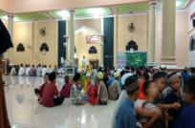 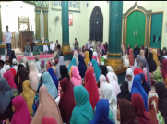 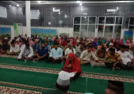

***Maulid Nabi Muhammad event at Simpang Tanjung (left), Dangku (center) and Baturaja (right)***

**B. Sponsorship**

In the 3rd Quarter (October – December 2019), PT TELPP had participated as sponsorship in the some activities as below :

* Support sport event for province level (PORPROV – Pekan Olah Raga Provinsi) that conducted in Prabumulih as host for this event on November 16 - 26, by construction of the rock wall climbing and paving block for the rock climbing venue area. Handed over of the building had conducted on October 18, 2019 from PT TELPP to Prabumulih government

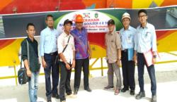 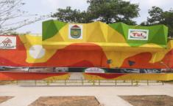

* Support Manpower Office of South Sumatera for New Enterpreneurship program on November 06, 2019 by distribution of equipment (mixer and oven) to support new enterpreunership in culinary business
* Support commemorate of the 73rd Anniversary of Muara Enim Regency on November 20, 2019 by distribution of 300 packages souvenir

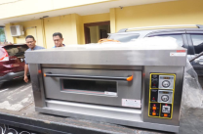 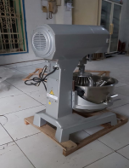 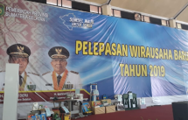

***Oven and mixer to support Manpower Office of South Sumatera program (new entrepreunership)***

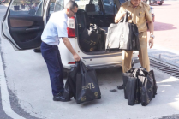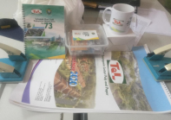

***Souvenirs to support the 73rd Anniversary of Muara Enim regency***

**COMMUNITY DEVELOPMENT**

1. **Economy / Local Business Empowerment**
   * + - Community Development thru local business empowerment program had conduct training for improvement and development of traditional cloth (specific batik) from South Sumatera known as Jumputan on November 22 – 24, 2019 at Learning Center of PT Tanjungenim Lestari Pulp and Paper.

This training collaboration with Family Welfare Empowerment (PKK – Pemberdayaan Kesejahteraan Keluarga) of Muara Enim

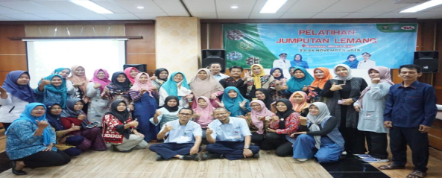   

***Training of Jumputan (traditional cloth/specific batik) for women club at villages surrounding of PT TELPP***

* + - * Distribution of sign board/name board for small local business (UMKM) that had supported by PT Tanjungenim Lestari Pulp and Paper on December 09 – 11, 2019

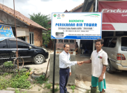 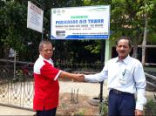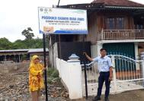

1. **Conservation**

* Contiunuing distribution of clean water to sommunities at 12 villages surrounding of PT Tanjungenim Lestari Pulp and Paper during dry season. This program to assist communities that during dry season have difficulties in getting clean water for consumption needs, that starting on Aug 2019 until December 2019

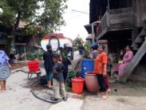 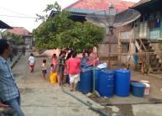 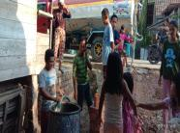

***Distribution of clean water in Banuayu, Dalam and Kuripan Induk village***

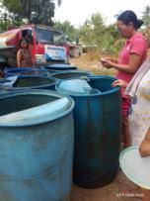 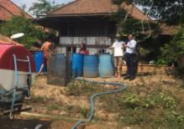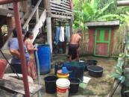

***Distribution of clean water in Lubuk Raman, Tanjung Menang and Muara Niru village***

* Distribution of Tedmond for community of Dalam village, as company commitment to fulfill one of point in the Agreement between PT TELPP and community when the community had conduct demonstration on November 04 – 06, 2019

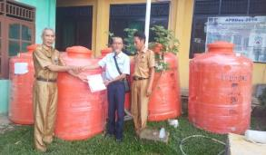 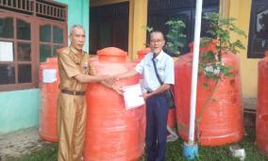

**III. Education / Scholarship Program**

* Monitoring scholarship program at ATPK (Academy of Pulp and Paper Technology) – Bandung (4 students) amd at Polytechnic of Sriwijaya – Palembang (19 students). 1st batch of scholarship program in Polytechnic of Sriwijaya (4 students) had graduate on August 25, 2019 (1 of student can’t fnisih the scholarship program) and 4 students of ATPK Bandung had graduate on September 26, 2019.

All of the students who had graduated from ATPK Bandung and Polytechnic of Sriwijaya Palembang were joint as management trainee at PT TELPP starting on November 11, 2019

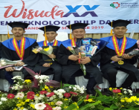 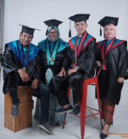

***Graduation of students of ATPK Bandung (left) and Polytechnic of Sriwijaya – Palembang (right)***

* Support school events :
  + - * Support SMANDA Event of SMAN 2 Prabumulih by distribution of trophy on October 05, 2019, SMANSABEL EVENT of SMAN 1 Belimbing by distribution of trophy on October 21, 2019 and support sports equipment, plantation and cleaning tools for SDN 37 Talang Langsatan on November 09, 2019

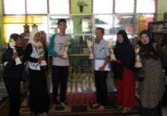 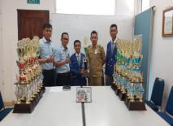 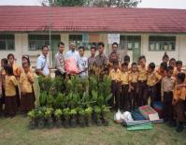

***Support school event at SMAN 2 Prabumulih (left), SMAN 1 Belimbing (center) and SDN 37 Talang Langsatan (right)***

* Training for teachers of Non Forman Education (TPA – Taman Pendidikan Al Qur’an) that conducted on December 02-03, 2019 at Learning Center of PT TELPP, participated by 50 teachers from TPA at villages surrounding of PT TELPP

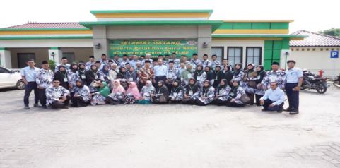

**IV. Lematang Lestari School Activities**

**A. Kindergarten**

* Participated in “Kindergarten Gebyar Competition” Muaraenim Regency level at Griya Serasan Hotel hall on October 07, 2019, and achieved 1st winner for creation from plasticine category and 2nd winner for move and song category.

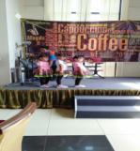

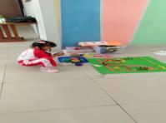

***Plasticine creation competition (left) and Move and Song competition (right)***

* Participated in Drumband Competition on October 12, 2019 at SMAN 2 Prabumulih and the drumband team achieved the 1st winner for drumband display (the best drumband performance) and the 1st winner for the best Mayoret in Prabumulih 2 Public Senior High School.

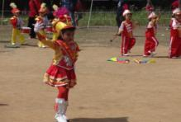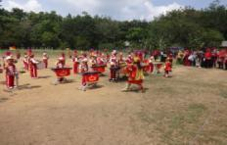

* Conduct inspiring class session onNovember 21, 2019 to introduce the children with “Chef” profession. The kindergarten headmaster and teachers are invited the chef to demonstrate the cooking skills and then the children try to applicate the decoration for the food serving. For this session the children decorating a bear fried rice and we ate the fried rice together
* Commemorate the Teacher’s Day on November 25, 2019 that conducted at Lematang Lestari Junior High School yard. All the YPTeL’s school staff and teacher conducted the flag ceremony together, and the kindergarten drumband team presented the drumband performance for the teachers and invited guests.

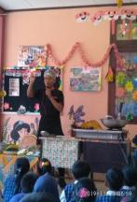

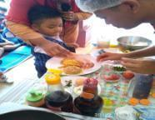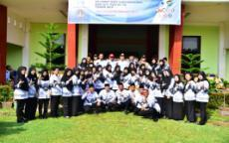

***Inspiring class session (left and center), and commemorate of the Teacher’s Day (right)***

* In the end of Odd Semester, kindergarten conducted the internal competition with the children. There were moving the block wood, put the ball in the basket, arrange letter competition.

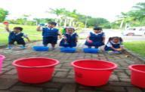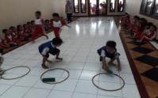

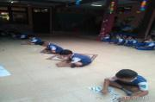

**B. Elementary School**

* On October 23-24, 2019 participated in Mathematic Festival Competition in On Sriwijaya University, in this competition our school selected in top 65 rank and went to semifinal session only.

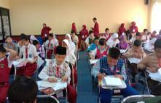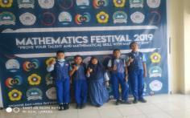

***Mathematic Festival Competition 2019***

* On October 29, 2019 there was Canteen audit by the National Agency of Drug and Food Control to make sure the food healthy in school areas.
* On November 7, 2019 for Outdoor Class Day (all school grades).
* On November 13 2019 for Class Market (to introduce the Function of Money) grade 1 and 2 and November 21st 2019 for DT and TD Immunization for grade 1, 2 and V from Community Healthy Center Rambang Dangku Sub Regency.
* On November 25, 2019 Lematang Lestari Elementary school presented the Marawis Performance to YPTeL teacher’s and invited guests in Teacher’s Day commemoration.

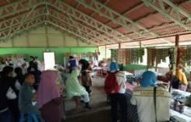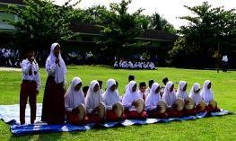

***Canteen audit for food healthy (left), and Marawis performance (right)***

* On December 3-5, 2019 the headmaster participated on Workshop on Assistance in Preparing School Government Assistance Reports Towards SNP Phase II of South Sumatra Province in 2019, at AMARIS HOTEL Palembang.
* On December 9-11, 2019 participated in Dissemination and Seminar on South Sumatra Province Quality Assurance School Results in 2019, at ZURI HOTEL Palembang.

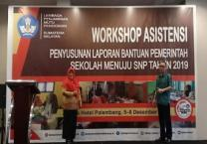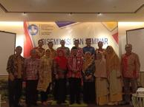

* On December 9-13, 2019 there was final semester assement for Lematang Lestari Elementary School Student and In December 16-18, 2019 after assesment, there was the classmeeting event.

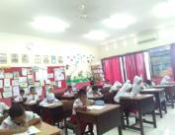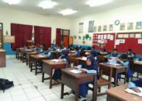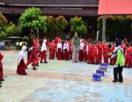

***Final semester assessment and class meeting event***

**C. Junior High School**

* Participated in the DOMINO Mathematic Competition in FIKP UNSRI to improve children's ability to compete in Math subject on October 22, 2019.
* On November 7-8, 2019 we conducted the National Examination Computer Based Simulation for student and teachers in Computer Laboratory. In November 18th, 2019 there was an online application for student to prepare the National Examination its called “Ruang Guru” socialization.

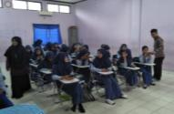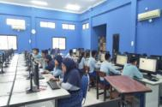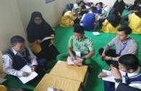

***Mathematic competition (left), and simulation of the National examination computer based (center and right)***

* Marubeni team visitation to school (Lematang Lestari elementary and junior high school) on December 03, 2019. They see learning and teaching process at school, facilities and infrastructure to support learning activities, and visit the garden at elementary school.

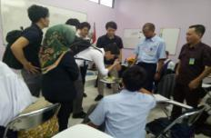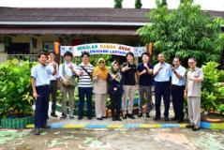

***Marubeni team visitation to Lematang Lestari elementary and junior high school***

**CSR Program for Next Quarter :**

* + - * 1. **Education**
  + **School packages distribution for students at villages Area 2 - 3**
    - * 1. **Local economy empowerment**
  + **Cooperation and collaboration with Rumah Ekonomi Smart (RES) of Muara Enim for mapping and development of small local business at villages surrounding of PT TELPP (on progress MoU between PT TELPP and RES)** 
    - * 1. **Infrastructure**
  + **Support construction/renovation of infrastructure/mosque/musholla at villages surrounding of PT TELPP : BPD Building in Gerinam, facility at Darussalam mosque in Banuayu, boundary monument of PT TeLPP in Ogan Ilir Regency, providing of Keranda and Bathing Place, etc**